

|  |  |  |  |  |
| --- | --- | --- | --- | --- |
| Year 12 Physics – Test 4 (Task 8)  **Wave Particle Duality and Special Relativity** | | | | |
|  | | | | |
| Name: | | | | |
| **Time allowed**: 50 minutes + 5 mins reading time (at discretion of teacher) | | | | |
| **Section** | Number of questions | Your Mark | Marks available | Percentage of Test |
| **Section One:**  Short answer | 4 |  | 17 | 28 |
| **Section Two**:  Extended answer | 3 |  | 30 | 50 |
| **Section Three:**  Comprehension  and data analysis | 1 |  | 13 | 22 |
|  | **Total** |  | **60** | **100** |

* Final answers should be given up to three significant figures and include appropriate units where appropriate. Questions containing the instruction "ESTIMATE" should be given two significant figures and include appropriate units where applicable.
* Scientific Calculators are allowed.
* No notes allowed.
* Formula sheet is provided.

**Section One:** Short answer

**Question 1 (5 mark)**

The newest addition to Space X’s fleet is a spaceship that can travel at velocities approaching the speed of light. It passes a space station near Saturn at 0.82c when alarm clocks to wake up workers set to 6:30am Earth time sound. After rising and getting ready for work the passengers aboard the spaceship note the time is 6:50am.

a) What time would the workers on the spaceship observe the clocks on the space station – to the nearest second?

(3 marks)

Time on the clock:_____hr____min____sec

b) When the workers on the space station observe that their clock’s show 6:50am, what time will the clocks on the spaceship read? Explain your answer.

(2 marks)

______________________________________________________________________________________

______________________________________________________________________________________

______________________________________________________________________________________

______________________________________________________________________________________

**Question 2 (4 marks)**

Large particle accelerators are capable of accelerating protons up to 99.0% of the speed of light. A ground based observer monitors a beam of protons accelerated by a particle accelerator on a spaceship which is moving past the earth at 75.0% the speed of light.

a) In the frame of the proton, what speed is the spaceship moving? (1 mark)

b) Calculate the speed of the protons as observed by the ground based observer in terms of c.   
 (3 marks)

____________ c

**Question 3 (4 marks)**

Light is said to exhibit a dual nature, behaving as both a wave and a particle. Using the contexts of *the photoelectric effect* and *Young’s double slit experiment*, describe the two phenomena and with the aid of diagrams explain which shows wave like behaviour and which shows particle like behaviour.   
  
 (4 marks)  
____________________________________________________________________________________

____________________________________________________________________________________

____________________________________________________________________________________

____________________________________________________________________________________

____________________________________________________________________________________

____________________________________________________________________________________

____________________________________________________________________________________

____________________________________________________________________________________

____________________________________________________________________________________

____________________________________________________________________________________

____________________________________________________________________________________

____________________________________________________________________________________

____________________________________________________________________________________

____________________________________________________________________________________

____________________________________________________________________________________

____________________________________________________________________________________

*Space for diagrams:*

**Question 4 (5 marks)**Muons are subatomic particles that were discovered in 1936 by researchers studying cosmic radiation. Most naturally-occurring muons are created when cosmic rays collide with atoms in the upper atmosphere, approximately 10 km above the Earth. A muon has a rest mass of 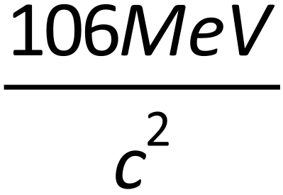 , a charge of -1 and an average lifetime of 2.2 × 10-6 s.

1. Muons travel at almost the speed of light. Calculate the average distance that a muon created in the upper atmosphere would travel before it decayed. Assume that its speed is equal to c and that there are no relativistic effects. (2 marks)

______________ m

Muons created by cosmic rays in the upper atmosphere can be detected by detectors on the Earth’s surface. This means that the muons have travelled much further than expected. An explanation of this phenomenon involves the effects of relativity.

1. Explain how relativity affects the muons and enables them to travel over a greater distance than that calculated in part (a). (2 marks)

**Section Two:** Extended answer

**Question 1 (12 marks)**

A group of astronauts is sent on a mission to collect data about an exoplanet that could possibly sustain human life. The spacecraft travels at a constant speed of 0.850c.

Two identical clocks that have been synchronised carefully on the Earth are to be used during the mission. One clock is left with an observer on Earth and the other is placed on the spacecraft. In the Earth’s frame of reference, the clocks are observed to tick once every second.

1. How much time, in seconds, would pass between ticks of the clock on the moving spacecraft in the spacecraft’s reference frame? (1 mark)

______________ s

1. How much time, in seconds, would appear to pass between ticks of the clock on the moving spacecraft according to an observer in the Earth’s frame of reference? (2 marks)

______________ s

1. Explain why the values in (a) and (b) are different. (3 marks)

__________________________________________________________________________________

____________________________________________________________________________________________________________________________________________________________________

__________________________________________________________________________________

____________________________________________________________________________________________________________________________________________________________________

When measured on the Earth, the spacecraft is 119 m in length.

1. Calculate the length of the moving spacecraft, in metres, as measured by an observer in the Earth’s frame of reference. (2 marks)

______________ m

1. Would the Earth observer notice any change in the height or width of the spacecraft? Explain your answer. (2 marks)

__________________________________________________________________________________

____________________________________________________________________________________________________________________________________________________________________

__________________________________________________________________________________

____________________________________________________________________________________________________________________________________________________________________

A rocket probe is launched forward from the spacecraft. The rocket probe moves at 0.500c relative to the spacecraft.

1. To an observer in the Earth’s frame of reference, what would be the speed of the rocket probe in m s-1? (2 marks)

______________ m s-1

**Question 2 (12 marks)**

According to one model of atoms, electrons in atoms move in stable circular orbits around the nucleus. In an atom modelled in this way, an electron is moving at 2.00 × 106 m s–1.

a.) Calculate the de Broglie wavelength of this electron. (2 marks)

____________________ m

b.) Describe how the wave nature of electrons can be used to explain the quantised energy levels in atoms. (3 marks)

The diagram shows some energy levels, in eV, of an atom.

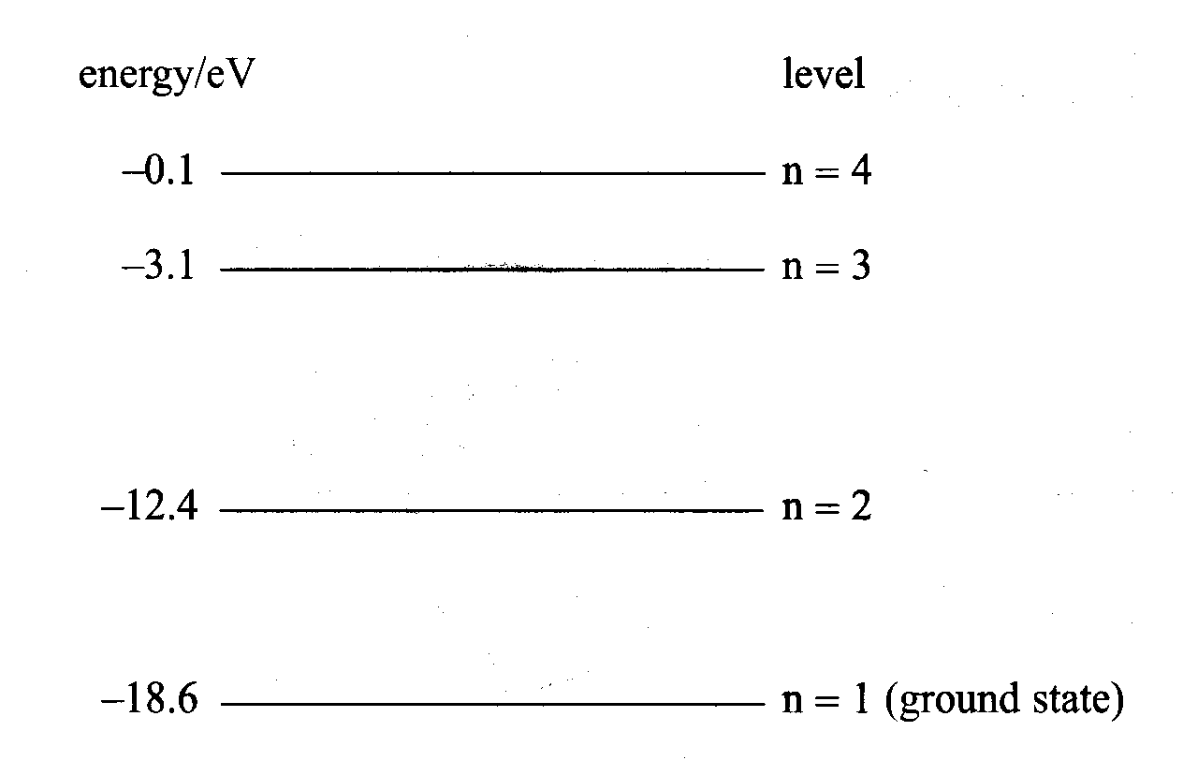

c) Explain how this atom emits a line spectrum following excitation. (2 marks)

____________________________________________________________________________________

____________________________________________________________________________________

____________________________________________________________________________________

____________________________________________________________________________________

____________________________________________________________________________________

d) How much energy, in eV, would be required to ionise the atom in its ground state?

(1 mark)

1. Photons of specific wavelengths are emitted from these atoms when they are **excited** by collisions with electrons. One of the emitted photons has an energy of 9.92 x 10‑19J.

i) Determine which transition is responsible for this emitted photon.

(1 mark)

ii) Draw an arrow on the energy level diagram to show the transition responsible for the emission of a photon with the shortest wavelength.

(1 mark)

f) In its ground state the atom is bombarded by a collision with an electron having 2.1 x 10‑18J of energy. Calculate the possible energies in electron volts, with which the electron could be scattered from the atom after the collision.

**(**3 marks)

**Question 3 (5 marks)**

Astronomers obtain spectra of the light from stars by passing the light collected in a telescope through a prism. The visible spectra is continuous and crossed by a series of sharp black lines:

Wavelength

4 x 10-7 m colour 8 x 10-7 m

Black Lines

1. What type of spectrum is this? ______________________________________ (1 mark)
2. The continuous spectrum is produced by the nuclear fusion processes in the star. What causes the black lines in the spectrum? (2 marks)

___________________________________________________________________________________

___________________________________________________________________________________

___________________________________________________________________________________

___________________________________________________________________________________

1. The composition of a star can be analysed by comparing it to **line emission spectra** produced in laboratories. Three spectra are shown below. Which one or more of these elements is likely to occur in the star?

___________________________ (2 marks)

ELEMENT A

Wavelength

4 x 10-7 m black 8 x 10-7 m

Coloured Lines

ELEMENT B

Wavelength

4 x 10-7 m black 8 x 10-7 m

ELEMENT C

Wavelength

4 x 10-7 m black 8 x 10-7 m

**Section Three:** Comprehension and data analysis

An experiment to demonstrate the particular nature of light is the photoelectric effect. Below is a table of results obtained from a photoelectric effect experiment.

|  |  |  |  |  |
| --- | --- | --- | --- | --- |
| f (x1015 Hz) | Ek (eV) |  | Metal | Minimum energy to eject electrons (nm) |
| 0.60 | 0.15 |  | Copper | 367 |
| 0.80 | 0.99 |  | Zinc | 232 |
| 1.00 | 1.81 |  | Sodium | 519 |
| 1.20 | 2.63 |  | Platinum | 168 |
| 1.40 | 3.47 |  | Calcium | 312 |
| 1.60 | 4.31 |  |

* 1. Plot a graph of kinetic energy (y-axis) versus frequency (x-axis) and use it to answer the questions that follow. (4 marks)
  2. Using your graph determine the work function of the metal. (2 marks)
  3. Calculate the minimum wavelength of light that would cause the metal to eject electrons (4 marks)
  4. Explain why red light would not cause electrons to be emitted from the metal no matter how intense it is.  
      (2 marks)

____________________________________________________________________________________

____________________________________________________________________________________

____________________________________________________________________________________

____________________________________________________________________________________

____________________________________________________________________________________

* 1. Determine the metal that was used in the experiment. (1 mark)

**End of Test**